**JavaScript Tooling & Workflows**

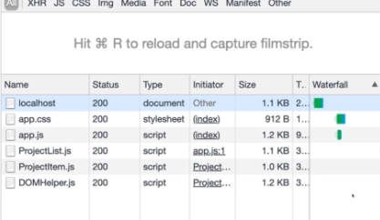

**Project Limitations & Why We Need Tools**

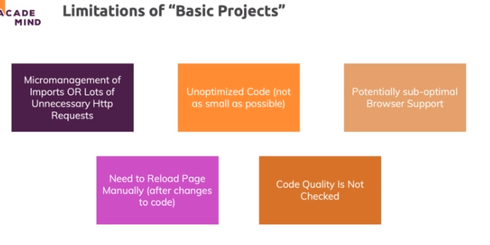

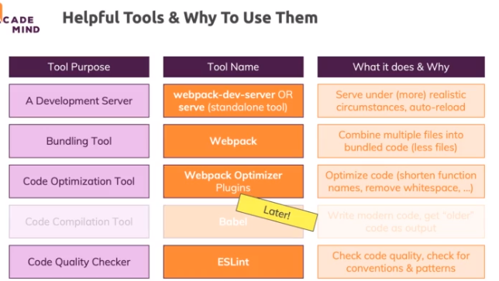

**Workflow Overview**

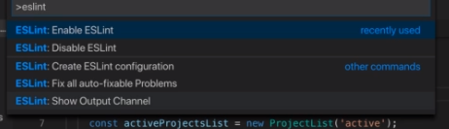

**Configuring ESLint**

ESLint **offers a lot of different options** so that you can really fine-tune it exactly to your requirements.

You can set up your own rules from the ground up (basically what we started doing in the lectures) but you can also use presets and pre-configured rulesets.

To fully understand all options you can configure in .eslintrc.json, this part of the official docs should be helpful: <https://eslint.org/docs/user-guide/configuring>

To explore all available rules and what they mean, explore this part of the official docs: <https://eslint.org/docs/rules/>

Want to use a preset? Here you go: <https://www.npmjs.com/search?q=eslint-config> (just click on one of the results and follow the instructions provided there)

Also check out the docs in general: <https://eslint.org/docs/user-guide/getting-started>

**Bundling with Webpack**

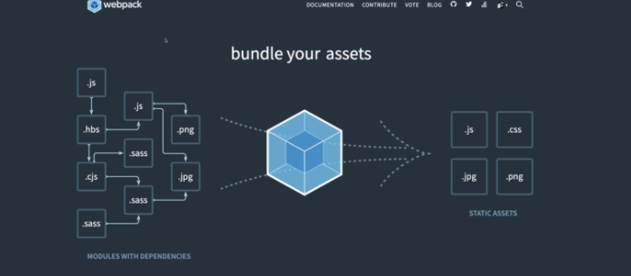

**Bonus: Multiple Entry Points**

In the example project, we only have **one main entry point**: app.js.

In bigger projects - with multiple HTML pages - you **might have multiple scripts** for the different pages (HTML files) you might be building. Hence you **might need more than one entry point** because you want to build more than one bundle (i.e. not every HTML page uses the same script).

**This can easily be configured with Webpack:**

Instead of

    1. entry: './src/app.js'

use

    1. entry: {

    2.     welcome: './src/welcome-page/welcome.js',

    3.     about: './src/about-page/about.js',

    4.     // etc.

    5. }

Now Webpack will **look up all these entry points** and create one bundle per entry point - you can then link to these bundles in your respective HTML files.

**A simple rule that makes sense for most projects is:**

*One entry point per HTML file because you typically have one script per HTML file.*

If you share a script across multiple HTML files or you have a file that does not need any script, you of course can deviate from that rule.

You can **learn more about multiple entry points** with these two resources:

* Code Splitting (i.e. generating more than one bundle): <https://webpack.js.org/guides/code-splitting/>
* Entry Point Configuration: <https://webpack.js.org/concepts/#entry>